WBUonline
School of Business

2. UNIVERSITY MISSION STATEMENT
Wayland Baptist University exists to educate students in an academically challenging, learning-focused and distinctively Christian environment for professional success, and service to God and humankind.

3. COURSE NUMBER & NAME:
MGMT 3324-VC01, Human Resource Management Practices

4. TERM:
Fall 2, 2020 (October 19 to December 19, 2020)

5. INSTRUCTOR:
Dr. Dave Rambow, Adjunct Professor of Management, School of Business

6. CONTACT INFORMATION:
Contact phone: cell & text (907) 242-4261
WBU Email: david.rambow@wayland.wbu.edu
Cell phone: Same as contact phone number

7. OFFICE HOURS, BUILDING & LOCATION:
No office hours: Contact professor by email or cell phone

8. COURSE MEETING TIME & LOCATION:
Meeting day & time: Course meets online beginning Monday, October 19 through WBUonline, BlackBoard.

9. CATALOG DESCRIPTION:
Impact of external and internal environment upon the functions and activities of personnel/human resource managers. Credit will not be awarded for both MGMT 3324 and HLAD 3324.

10. PREREQUISITE:
MGMT 3304: Principles of Management

11. REQUIRED TEXTBOOK AND RESOURCE MATERIAL: The course textbook is an eBook. Within the course BlackBoard site is a tab titled “Automatic eBook.”

- Roberts, G. (2015). Christian Scripture and Human resource management: Building a path of servant leadership through faith. Palgrave McMillian ISBN: 9781-13744-0662
- Noe, R., Hollenbeck, J., Gerhart, B., and Wright, P. (2020). Fundamentals of human resource management (8th ed.). McGraw-Hill ISBN: 978-1260565768
NOTE: The cost of the eBook is included at registration. It is acceptable that those students who desires to purchase a hard copy of the course textbook may do so. HOWEVER, it is imperative that students who elect to buy a hardcopy take action to OPT-OUT of the eBook in the classroom link No-Later-Than August 24. If actions to OPT-OUT is not completed by August 24, then a student will be charged for the eBook.

12. OPTIONAL MATERIALS:
- Publication Manual of the American Psychological Association (APA), 7th Edition.
- Learning Resource Center: The Wayland Library (Learning Resource Center) is available to all Wayland students at: http://library.wbu.edu . Tutorials for accessing library resources are linked from the homepage.
- Supplemental reading material will be distributed through BlackBoard.

13. COURSE OUTCOMES AND COMPETENCIES:
- Outline the domestic as well as global components of human resource management.
- Explain the importance of development of human capital (training) and explain models of training that occur through human resources.
- Compare strategies of cost containment and interpret legal requirements that exist through human resource management.
- Demonstrate readiness for the Professional Human Resource Certification Examination.

14. ONLINE ATTENDANCE REQUIREMENTS:
As stated in the 2020-2021 Wayland Baptist University Academic Catalog, students are expected to participate in all required instructional activities in their courses. Online courses are no different in this regard; however, participation must be defined in a different manner. Student “attendance” in an online course is defined as active participation in the course as described in the course syllabus. The instructor in online courses is responsible for providing students with clear instructions for how they are required to participate in the course. Additionally, the instructor is responsible for incorporating specific instructional activities within the course and will, at a minimum, have weekly mechanisms for documenting student participation. These mechanisms may include, but are not limited to, participating in a weekly discussion board, submitting/completing assignments in Blackboard, or communicating with the instructor. Students aware of necessary absences must inform the professor with as much advance notice as possible in order to make appropriate arrangements. Any student absent 25 percent or more of the online course, i.e., non-participatory during 2 or more weeks of an 8-week term, may receive an F for that course. The instructors may also file a Report of Unsatisfactory Progress for students with excessive non-participation. Any student who has not actively participated in an online class prior to the census date for any given term is considered a “no-show” and will be administratively withdrawn from the class without record. To be counted as actively participating, it is not sufficient to log in and view the course. The student must be submitting work as described in the course syllabus. Additional attendance and participation policies for each course, as defined by the instructor in the course syllabus, are considered a part of the university’s online attendance policy.

15. STATEMENT ON PLAGIARISM & ACADEMIC DISHONESTY:
Wayland Baptist University observes a zero-tolerance policy regarding academic dishonesty. Per university policy as described in the academic catalog, all cases of academic dishonesty will be reported, and second offenses will result in suspension from the university (2020-2021 WBU Academic Catalog).

16. DISABILITY STATEMENT:
In compliance with the Americans with Disabilities Act of 1990 (ADA), it is the policy of Wayland Baptist University that no otherwise qualified person with a disability be excluded from participation in, be denied the benefits of, or be subject to discrimination under any educational program or activity in the university. The Coordinator of Counseling Services serves as the coordinator of students with a disability and should be contacted concerning accommodation requests at (806) 291-3765. Documentation of a disability must accompany any request for accommodations (2020-2021 WBU Academic Catalog).

17. COURSE REQUIREMENTS and GRADING CRITERIA:
- All college-level work well be typed. All assignments and case studies will be typed. Course assignments submitted late may be subject to a reduced by 1.5% for each day an assignment is late. For the sake of time management, see paragraph 18, Tentative Schedule.

- Course Assignments: All course assignments are due by mid-night in the time zone a student resides on the dates indicated for various assignments within the course syllabus, paragraph 18: Tentative Schedule. All course work must be a student’s “original work.” This means that the student authored all assignments. Original work further means that when a student applies the ideas, concepts, theories, and/or principles from another author, then the student properly credits the source.

- WBU Email Accounts: By October 23, all students enrolled in this course will have an active WBU email account. Additionally, throughout this course, students will check their respective WBU email accounts as a minimum once a week beginning the first day of Fall 2 term, Monday, October 19, 2020.

- Preparation, Participation, and Engagement: The learning process mandates that a student prepare for each online session by (1) reading the assigned chapter(s) (2 listing to session video lectures, and (3) providing the appropriate response back to the instructor after listing each video lecture; participate by 1) reading individual and group assignment feedback documents and providing the appropriate response back to the instructor after reading feedback documents, and engage by asking meaningful questions when course material or feedback is not clear. The rubric below will be used to evaluate preparation, participation, and engagement. Preparation, Participation, and Engagement represent 10% of the course total grade.

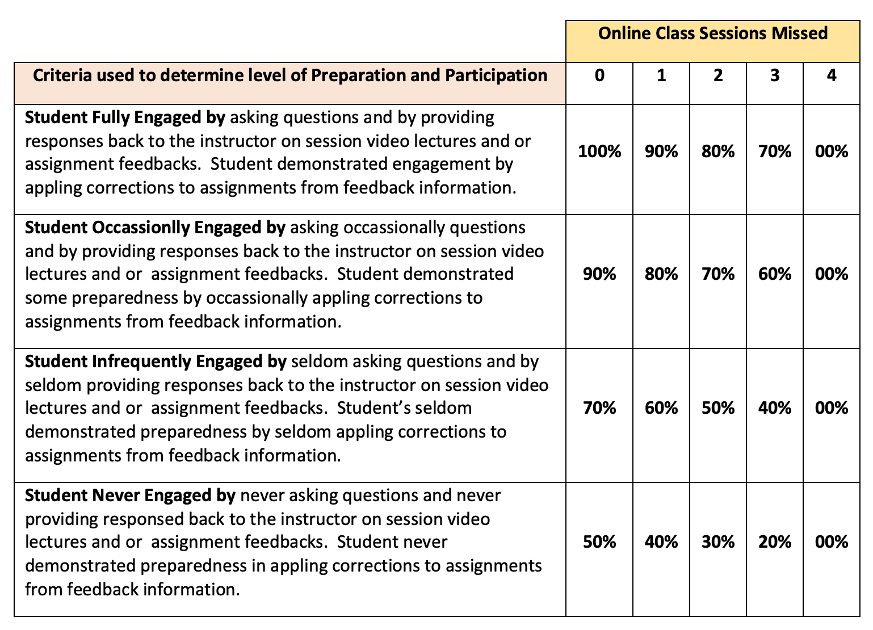
- Weekly Topic Response (WTR) Assignments: WTR prompts are found the courser BlackBoard tab titled: Weekly Topic Response. WTR assignments will be assessed for a maximum score of 8.0 points. Additionally, peer-to-peer feedback response to one other class member’s will be assessed for a maximum score of 1.0 points. The total possible points for a WTR response are 9.0 points. The Eight required WTR assignments represent 72% of the total grade.

- One HR Case Study Analyses Assignment: Graduate students will conduct an HR Case Study analysis and write an HR Case Study analysis paper. The due date for the HR Case Study analysis paper is found in paragraph 18, Tentative Schedule. The HR Case Study paper is worth 18% for a total of 34% of the total course grade.

- Technology Requirements:
Students are expected to perform basic computer hardware and software proficiency with commonly used software programs and maintain current software updates. Additionally, students are responsible to maintain their respective ISP service. To view and listen to video PowerPoint lectures and to enter schedule Collaborate Ultra session, graduate students will use the Google Chrome browser. If a student’s PC does not have the Google Chrome browser, then the browser software can be downloaded for free at the Google Chrome web site.

- Means for Assessing Outcome Competencies:

- Procedures used to compute final course grade:
  - Preparation, Participation, and Engagement: 10%
  - Eight (8) BlackBoard Weekly Topic Response (WTR) (8 x 9 points each): 72%
  - One HR Case Study: 18%
- Grading Criteria: Letter grades from "A" to "F" will be issued to student based on individual work. The grading criteria are listed below:

Grade | Points | Percentage
A | 100.0 to 89.50 points | 100% to 90%
B | 89.49 to 79.50 points | 89% to 80%
C | 79.49 to 69.50 points | 79% to 70%
D | 69.49 to 59.50points | 69% to 60%
F | 59.49 points and below | 59% and below

17.1 Include Grade Appeal Statement: “Students shall have protection through orderly procedures against prejudices or capricious academic evaluation. A student who believes that he or she has not been held to realistic academic standards, just evaluation procedures, or appropriate grading, may appeal the final grade given in the course by using the student grade appeal process described in the Academic Catalog. Appeals may not be made for advanced placement examinations or course bypass examinations. Appeals are limited to the final course grade, which may be upheld, raised, or lowered at any stage of the appeal process. Any recommendation to lower a course grade must be submitted through the Vice President of Academic Affairs/Faculty Assembly Grade Appeals Committee for review and approval. The Faculty Assembly Grade Appeals Committee may instruct that the course grade be upheld, raised, or lowered to a more proper evaluation.”

18. TENTATIVE SCHEDULE
The tentative schedule provided below indicates specific course activities, assignments, and due dates. This schedule is provided to assist student’s in time management. Make time to review the schedule and note activities and due dates of assignments.
Date & Session # | Homework, Activities and Assignments
HOMEWORK for  Session 1 | Prior to first class session  Print and read course syllabus  Establish a WBU email account and send an email message to the instructor at david.rambow@wayland.wbu.edu from WBU email account. (Instructions for establishing a WBU email account is located within the course BlackBoard site.
Session #1  October 19 – October 25 | Read Chapters 1 & 2 - Noe  Using only Google Chrome, listen to 4 voice embedded video lectures found within BlackBoard, Session 1 tab: (1) Course Introduction and Overview, (2) Systems Thinking, (3) Chapter 1, and (4) Chapter 2.  Session 1 Assignment: Complete Weekly Topic Response (WTR) #1 prompt by Sunday, October 25.

Date & Session # | Homework, Activities and Assignments
HOMEWORK for Session 2: | Session 2: Read Chapters 3 & 4 - Neo  Session 2 Homework:  - Assignment - Complete Weekly Topic Response #2 prompt.  - In Session 2 Tab - download and read HR Case Study and download HR Case Study paper template and rubric.  - The HR Case Study analysis paper is due Friday, December 18.
Session #2  October 26 – November 1 | Using only Google Chrome, listen to 3 voice embedded video lectures found within BlackBoard, Session 2 tab: (1) Chapter 3, (2) Chapter 4, and (3) Scholarly Thinking and Writing  Session 2 Assignment: Complete Weekly Topic Response #2 prompt and provided feedback to one peer by Sunday, November 1.
HOMEWORK for Session 3: | Session 3: Read Chapters 5 & 6 – Neo  Session 3 Homework:  - Assignment - Complete Weekly Topic Response #3 prompt.  - Work HR Case Study paper – due Friday, November 18. Use HR Case Study paper template located within Session 2 Tab.
Session #3  November 2 –  November 8 | First live Collaborative Ultra session, Tuesday, November 3. For students NOT familiar with BlackBoard Collaborative Ultra, I produced a brief voice PPT video discussion which is available within the tab titled: Collaborate Sessions. Use only Google Chrome to access this live Collaborate Session.  Using Google Chrome, listen to 2 voice embedded video lectures found within BlackBoard, Session 3 tab: (1) Chapter 5 and (2) Chapter 6.  Session 3 Assignments: Complete Weekly Topic Response #3 prompt and provided feedback to one peer by Sunday November 8.
HOMEWORK for Session 4: | Session 4: Read Chapters 7 & 8 – Neo  Session 4 Homework:  - For EXTRA CREDIT complete Weekly Topic Response #4 prompt.  Work HR Case Study is due Friday, December 18 by midnight (Central Time Zone).

Date & Session # | Homework, Activities and Assignments
Session #4  November 9 –  November 15 | Using Google Chrome, listen to 2 voice embedded video lectures found within BlackBoard, Session 4 tab: (1) Chapter 7 and (2) Chapter 8.  Session 4: For EXTRA CREDIT, complete Weekly Topic Response #4 prompt by Sunday, November 15.
HOMEWORK for Session 5: | Session 5: Read Chapters 9 & 10 - Neo  Session 5 Homework: Assignment - complete Weekly Topic Response #5 prompt.
Session #5  November 15–  November 22 | Using Google Chrome, listen to session 5 voice embedded video lectures found within BlackBoard, Session 5 tab: (1) Chapter 9 and (2) Chapter 10.  Session 5 Assignments: Complete Weekly Topic Response #5 prompt and provided feedback to one peer by Sunday, November 22.
Thanksgiving Break:
November 23 to November 27
To you and your loved ones enjoy a blessed Thanksgiving Day
HOMEWORK for Session 6: | Session 6: Read Chapters 11 & 12 – Neo  Session 6 Homework:  - Assignment - Complete Weekly Topic Response #6 prompt.  - Work HR Case analysis paper is due Friday, December 18.
Session #6  November 30 –  December 6 | Using Google Chrome, listen to 2 voice embedded video lectures found within BlackBoard, Session 6 tab: (1) Chapter 11 and (2) Chapter 12.  Session 6 Assignments: Complete Weekly Topic Response #6 prompt and provided feedback to one peer by Sunday, December 6.
HOMEWORK for Session 7: | Session 7: Read Chapters 13 & 14 – Neo  Session 7 Homework:  - Assignment - Complete Weekly Topic Response #7 prompt.  - Work HR Case Study analysis paper – due Friday, December 18 by midnight (Central Time Zone).

Date & Session # | Homework, Activities and Assignments
Session #7  December 7 –  December 13 | Final live Collaborative Ultra session, Tuesday, September 29. Use ONLY Google Chrome to access Collaborate session.  Using only Google Chrome, listen to 2 voice embedded video lecture found within BlackBoard, Session 7 tab: Chapters 13 & 14.  Session 7 Assignments: Complete Weekly Topic Response #7 prompt by Sunday, December 13.
HOMEWORK for Session 8: | Assignment - Complete Weekly Topic Response #8 prompt.  Work HR Case Study analysis paper – due Friday, December 18.
Session #8  December 14 –  December 19 | UPLOAD HR Case Study analysis paper through the “Assignment” link within Session 8 Tab.

NOTE: The professor reserves the right to alter this schedule as needed. Any revisions to this study plan will be announced through email to student’s WBU email account.

19. ADDITIONAL INFORMATION

  - Students’ WBU Email Accounts: By week 1 of the term, graduate students will establish a WBU email account, and send an email to the instructor using the student’s WBU email account. This is a mandatory requirement. If a graduate student experiences difficulty establishing a WBU email account, then contact the instructor via the telephone number provided in this syllabus. NOTE: My email address is david.rambow@wayland.wbu.edu

  - Students will check their respective WBU email accounts every week.

  - Course/Assignment Information:

    - Students will need Internet to access BlackBoard. Additionally, students will need a computer with speakers or headsets in order to listen to voice embedded video PowerPoint lectures.

    - All assignments are due is NLT 11:59 p.m. for the time zone the student resides. Late assignments are subject to score reduction.

    - All written assignments will be assessed on the basis of 1) content, 2) grammar and punctuation, and 3) proper application of APA writing style (7th edition).

    - Questions concerning grades (scores) received on assignments will be resolved within one week after the assignment has been assessed.

    - All work will be the original work of the individual student. Academic honesty is expected of all students. Plagiarism, cheating, and other acts that lack academic honesty will result in a zero (0) for an assignment, and additional actions as outlined within online WBU Academic Catalog 2020-2021, may be taken by the instructor.

    - The student’s first point-of-contact for this course is the professor. If the professor cannot provide a satisfactory response, then the graduate students will next contact the student’s respective campus dean.

- Expectations and Responsibilities:

    - Instructor: As the instructor, I am responsible to communicate and instruct the course standards by presenting clear, meaningful video lectures, providing students timely and useful feedback on assignments, and responding back to students in a timely manner.

    - Student: As member of this course, my expectations are that you:
  - will read this syllabus completely and understand your responsibilities.
  - will enter each on-line class session having read the assigned chapter(s) and having listened to the corresponding chapter lectures posted within BlackBoard.
  - will complete and turn assignment at the due date.
  - will present questions when text and /or lectured material are unclear.
  - will commit yourself to the learning process.
  - will communicate with the professor.

