

VIRTUAL CAMPUS
SCHOOL OF BUSINESS

SYLLABUS

1. Mission Statement: Wayland Baptist University exists to educate students in an academically challenging,
learning-focused and distinctively Christian environment for professional success and service to God and humankind.

2. Course: COSC 2311 – VC01, Computer Applications
This syllabus contains a general overview of the course only. It should NOT be considered as a substitute for reading and understanding all the pages of this website. Once you have read and understood everything contained herein, you are required to send to me an e-mail message containing all of the following:
- Your Full Name
- The name of the WBU location where you registered for this course
- A Statement of Understanding as follows:
"I have read the syllabus for this course. I understand the course requirements and procedures. Since grades are an indicator of personal effort and performance, I understand that it is my responsibility to earn the grade I desire in this class."
- Submit an alternate e-mail address to the WBU address. There are times when I may need to contact you other than through WBU.

3. Term: Summer 2017

4. Instructor: Deborah M. Pineau, EdD

5. Office Phone Number and WBU Email Address: 940-781-2094 before 7 p.m.
E-mail: deborah.pineau@wayland.wbu.edu (checked often) or dpineau@wf.net (checked more often).

6. Office Hours, Building, and Location: Call before 7 p.m.

7. Class Meeting Time and Location: Online only

8. Catalog Description: Enhanced personal productivity and problem solving skills using knowledge work tools (spreadsheets, presentation graphics, word processing, data-base management, Internet, and electronic mail); use of integrated software; design and use of small information systems for individuals and groups. Examinations available for demonstrated competency – waiver of requirement examination, $30; for credit examination (advanced standing), 1/3 campus tuition. Neither examination requires a proctor and neither examination is appealable. Failure of either exam requires the student to take and pass COSC 2311.

9. Prerequisites: None

10. Required Textbook and Resources:

BOOK | AUTHOR | ED | YEAR | PUBLISHER | ISBN# | UPDATED
TestOut Office Pro LabSim | Testout | 1st | 2016 | TestOut | 9781-93508-0527 | 12/1/15

NOTE: The TestOut certification test is required of all students! Instructors may decide how to assign points, but all students must take the exam.

11. Optional Materials: None

12. Course Outcome Competencies:

- Understand how Microsoft Office applications work with the computer’s hardware and other software
- Demonstrate efficiency in using external document sharing and storage technologies
- Create, modify, rename, and move documents created in Office applications
- Analyze, filter, format, and sort data in Excel and Access, and use charts and graphs to present information
- Import and export data between Office applications and other computer programs
- Format Office applications with templates and theme sets
- Create citations and bibliographies in Microsoft Word
- Build presentations with animation in Microsoft PowerPoint

13. Attendance Requirements: There are no regularly scheduled meetings for this class. Rather, student participation will be considered attendance. This participation will be reflected by timely submission of homework questions and labs. Student/instructor interaction will take the form of correspondence via e-mail. Student will forward their e-mail address to the instructor within the first week of the scheduled course.

Students enrolled in this class should make every effort to submit homework and labs on time. Due dates for each assignment are listed on the syllabus. All non-participation in course activities will be explained to the instructor. Any student who misses 25% or more of the scheduled assignments will receive an unsatisfactory progress report which will be filed with the campus dean. Missing 25% or more of the scheduled assignments will result in a grade of F in the course.

Student/Instructor interaction will take the forms of correspondence via e-mail. Students will forward their e-mail address to the instructor within the first week of the schedule for the course and ensure that Virtual Campus has the most current e-mail address. Obtaining an e-mail address is the responsibility of the student.

From Policy 8.4.2
Online Students - Students are expected to participate in all required instructional activities in their courses. Online courses are no different in this regard; however, participation must be defined in a different manner.

a. Student “attendance” in an online course is defined as active participation in the course as described in the course syllabus. Instructors in online courses are responsible for providing students with clear instructions for how they are required to participate in the course. Additionally, instructors are responsible for incorporating specific instructional activities within their course and will, at a minimum, have weekly mechanisms for documenting student participation. These mechanisms may include, but are not limited to, participating in a weekly discussion board, submitting/completing assignments in Blackboard, or communicating with the instructor.

b. Students aware of necessary absences must inform the professor with as much advance notice as possible in order to make appropriate arrangements.

c. Any student absent 25 percent or more of the online course, i.e., non-participatory during 3 or more weeks of an 11 week term, may receive an F for that course. Instructors may also file a Report of Unsatisfactory Progress for students with excessive non-participation.

d. Any student who has not actively participated in an online class prior to the census date for any given term is considered a "no-show" and will be administratively withdrawn from the class without record. To be counted as actively participating, it is not sufficient to log in and view the course. The student must be submitting work as described in the course syllabus.

e. Additional attendance and participation policies for each course, as defined by the instructor in the course syllabus, are considered a part of the university’s attendance policy.

14. Statement on Plagiarism and Academic Dishonesty: Wayland Baptist University observes a zero tolerance policy regarding academic dishonesty. Per university policy as described in the academic catalog, all cases of academic dishonesty will be reported and second offenses will result in suspension from the university.

15. Disability Statement: “In compliance with the Americans with Disabilities Act of 1990 (ADA), it is the policy of Wayland Baptist University that no otherwise qualified person with a disability be excluded from participation in, be denied the benefits of, or be subject to discrimination under any educational program or activity in the university. The Coordinator of Counseling Services serves as the coordinator of students with a disability and should be contacted concerning accommodation requests at (806) 291- 3765. Documentation of a disability must accompany any request for accommodations.”

16. Course Requirements and Grading Criteria:

**INITIAL LOG-IN TO THE COURSE**
**Use BlackBoard to log into TestOut/LabSim. This initial log-in through BlackBoard establishes the link between the 2 programs. This link allows the labs completed in LabSim for grade to be recorded in BlackBoard gradebook. Without this initial link, grades will not be transferred. Refer to Announcements for instructions on logging into LabSim through BB. Do not log into LabSim directly.

NUMERIC COURSE GRADE (out of 100 %)-Grade is computed as a weighted average.
Tests have a greater weight in the final grade than do the homework assigments and labs, but both are important to receive a good grade
- Tests - 55% (Final Projects for Word, Excel, PowerPoint, and Access – Performance based)
- Lab Assignments - 20% (Listed on Syllabus and found in LabSim)
- Homework Assignments - 20% (Listed on Syllabus and found in BB)
- Certification Exam – 5% (Found in LabSim under Certification)

LETTER GRADE DETERMINATION:
The following table will be used in converting your numeric grade into an official letter grade for the course:
- 90 - 100 % = A
- 80 - 89 % = B
- 70 - 79 % = C
- 60 - 69 % = D
- 0 - 59% = F

LABS:
As you progress through the chapters, you are given the opportunity to try new information by completing the chapter labs. These labs help you to practice the skills and information about which you have read. The tutorial labs may be accomplished numerous times. The final labs will allow you to demonstrate to me the knowledge that you have gained through the tutorial and written text material. To complete each lab, you will use the skills that you learn throughout the chapter in each section of the textbook. Not all of the labs will be recorded in the BB gradebook. Most labs provide practice of the learned skill to enable you to complete the Challenge Labs which are graded. Graded labs are identified on the syllabus. Submission of labs will be accomplished through TestOut/LabSim.

TESTS:
There are no written tests but you will be completing the final project for Word, Excel, PowerPoint, and Access in TestOut/LabSim. Four final projects total. These will “test” the skills you have learned and practiced in the sections. These performance exams will be your final assessment in each section. Upon completion of the course, you will take the certification exam. The certification exam will count for 5% of your final grade.

STUDENT APPEALS:
Students shall have protection through orderly procedures against prejudices or capricious academic evaluation. A student who believes that he or she has not been held to realistic academic standards, just evaluation procedures, or appropriate grading, may appeal the final grade given in the course by using the student grade appeal process described in the Academic Catalog. Appeals may not be made for advanced placement examinations or course bypass examinations. Appeals are limited to the final course grade, which may be upheld, raised, or lowered at any stage of the appeal process. Any recommendation to lower a course grade must be submitted through the Executive Vice President/Provost to the Faculty Assembly Grade Appeals Committee for review and approval. The Faculty Assembly Grade Appeals Committee may instruct that the course grade be upheld, raised, or lowered to a more proper evaluation.

17. SCHEDULE (* Indicates Graded Activity)
Date Due | Activity
Week 1 | Course Initialization Week  Secure your access code to TestOut/LabSim  Read Student Instructions on TestOut/LabSim Getting Started  Review all associated pages on BlackBoard (BB)  Create the statement of understand and forward to instructor  (Important: Include your full name on all communications.)  Read Unit I Computer Basics  Lesson 1.1 Computer Hardware  Lesson 1.2 The Window Operating System  Lesson 1.3 File Management  Lesson 1.4 Networking and System Updates  Lesson 1.5 Online Safety and Security  Lesson 1.6 Microsoft Office Application Features  Work on Questions for Computer Basics and Word in BB*  (Complete Questions as you read and submit in BB by Week 3*)
Week 2 | Read Unit II: Microsoft Word Lessons 2.1 to 2.6  Lesson 2.1 Introduction to Word  Lesson 2.2 Creating Documents  Lesson 2.3 Managing and Printing Documents  Lesson 2.4 Modifying Fonts  Lesson 2.5 Formatting Paragraphs  Lesson 2.6 Formatting Pages  Continue with Homework Computer Basics & Word Questions in BB*  (Complete Questions as you read and submit in BB by Week 3*)  In Test/Out/LabSim Complete Lab 2.2.5 * and Lab 2.6.6*
Week 3 | Read Unit II: Microsoft Word Lessons 2.7 to 2.12  Lesson 2.7 Editing Documents  Lesson 2.8 Inserting Illustrations and Other Elements  Lesson 2.9 Creating and Formatting Tables  Lesson 2.10 Using Themes, Styles, and Templates  Lesson 2.11: Managing References  Lesson 2.12: Managing Headers, Footers, and Sections  Complete Computer Basics and Word Questions in BB &  Submit in BB for grade*  In TestOut/Lab/Sim Complete Lab 2.8.5*
Week 4 | Complete Word Final Project (in TestOut/LabSim)*  Read Unit III: Microsoft Excel Lessons 3.1 to 3.3  Lesson 3.1 Introduction to Excel  Lesson 3.2 Creating and Managing Workbooks  Lesson 3.3 Organizing and Entering Data  Work on Questions for Excel in BB*  (Complete as you read and submit in BB by Week 6*)  In TestOut/LabSim Complete Lab 3.3.6 *
Week 5 | Read Unit III: Microsoft Excel Lessons 3.4 to 3.6  Lesson 3.4 Changing Properties and Printing Worksheets  Lesson 3.5 Formatting Cells  Lesson 3.6 Entering Simple Formulas  Work on Questions for Excel in BB*  (Complete as you read and submit in BB by Week 6*)  In TestOut/LabSim Complete Lab 3.6.5 *
Week 6 | Read Unit III: Microsoft Excel Lessons 3.7 to 3.9  Lesson 3.7 Using Advanced Functions  Lesson 3.8 Analyzing Data in Charts  Lesson 3.9 Analyzing Data in Tables  Complete Excel Questions in BB & Submit in BB for grade*  Complete Excel Final Project (in TestOut/LabSim)*
Week 7 | Unit IV: Microsoft PowerPoint Lessons 4.1 to 4.4  Lesson 4.1 Introduction to PowerPoint  Lesson 4.2 Creating and Managing Presentations  Lesson 4.3 Formatting Textual Content  Lesson 4.4 Designing Slides  Work on Questions for PowerPoint in BB*  (Complete as you read and submit in BB by Week 8*)  In TestOut/LabSim Complete Lab 4.2.5 *
Week 8 | Read Unit IV: Microsoft PowerPoint Lessons 4.5 to 4.9  Lesson 4.5 Using the Slide Master  Lesson 4.6 Formatting Illustrations and Tables  Lesson 4.7 Formatting Pictures and other Media  Lesson 4.8 Applying Animations and Transitions  Lesson 4.9 Delivering Presentations  Complete PowerPoint Questions in BB & Submit in BB for grade*  In TestOut/LabSim Complete Labs 4.7.4 * & 4.8.5 *
Week 9 | Complete PowerPoint Final Project (in TestOut/LabSim)*  Read Unit V: Microsoft Access Lessons 5.1 to 5.3  Lesson 5.1 Introduction Access  Lesson 5.2 Managing Databases  Lesson 5.3 Designing and Creating Tables  Work on Questions for Access in BB*  (Complete as you read and submit in BB by Week 10*)  In TestOut/LabSim Complete Lab 5.3.8 *
Week 10 | Read Unit V: Microsoft Access Lessons 5.4 to 5.6  Lesson 5.4 Using Simple Queries  Lesson 5.5 Creating Forms  Lesson 5.6 Creating Reports  Complete Access Questions in BB & Submit in BB for grade*  In TestOut/LabSim Complete Lab 5.6.6 *  --Please accomplish Course Evaluation at this time. Link will be made available through VC.
Week 11 | Complete Access Final Project (in TestOut/LabSim)*  Complete the Certification Exam in LabSim*

18. Additional information as desired by the faculty member.

ACADEMIC HONESTY:
University students are expected to conduct themselves according to the highest standards of academic honesty. Academic misconduct for which a student is subject to penalty includes all forms of cheating, such as illicit possession of examinations or examination materials, forgery, or plagiarism. (Plagiarism is the presentation of the work of another as one's own work.)

The university reserves the right, through proper procedures, to place any student on probation or suspension who violates academic integrity and regulations by providing misleading or incomplete information to the university, by falsification of university records, by plagiarizing, by exhibiting improper classroom demeanor, or by engaging in any other form of academic dishonesty

Disciplinary action for academic misconduct is the responsibility of the faculty member assigned to the course. The faculty member is charged with assessing the gravity of any case of academic dishonesty, and with giving sanctions to any student involved. Penalties that may be applied to individual cases of academic dishonesty include one or more of the following:
1. Written reprimand.
2. Requirement to redo work in question.
3. Requirement to submit additional work.
4. Lowering of grade on work in question.
5. Assigning the grade of F to work in question.
6. Assigning the grade of F for course.
7. Recommendation for more severe punishment. (See Student Handbook for further information).

The faculty member involved will file a record of the offense and the punishment imposed with the division chair and the Vice President for Academic Services/Graduate Studies. The Vice President for Academic Services/Graduate Studies will maintain records of all cases of academic dishonesty reported for not more than two years.

Any student who has been penalized for violations of academic integrity - academic dishonesty, improper classroom demeanor, or providing false or misleading information - has the right to appeal the judgment or the penalty assessed. The appeals procedure will be the same as that specified for Student Grade Appeals, (policy 8.2.1).

***Important--read information below before logging into LabSim

****Student Information for Using the LabSim for COSC2311

This document contains information on how to purchase and use the LabSim software for the COSC2311 course for the Spring-PLV term. Your initial log-in to the course material should be through BlackBoard link.

There will not be a book for this course. The TestOut LabSim program contains the text. You will need to purchase it, and that can be done in either of the following two ways:

- From the WBU University Bookstore. When you purchase the LabSim, they will give you the activation code. Advantage – you can utilize financial aid for this purchase.
- Directly from the TestOut Office Pro LabSim Website. Go to www.testout.com and enter Promotion Code: 14-232TA in the Enter Promotion Code box located in the lower right corner.
- Academic price: May be available for TestOut Office Pro LabSim
- To validate the order you need to enter school name and teacher name. (Be sure the school name matches exactly as listed below. It is recommended that students copy and paste the school name into the order system.)
School Name: Wayland Baptist University
Teacher Name: Katrina Smith
- No sales tax except for UT/WA residents.
- You will be emailed your LabSim activation code and instructions to access LabSim. Please use these instructions to activate the TestOut Office Pro LabSim. For the COSC 2311 class you must activate the 16-digit code within Blackboard.
- The LabSim license is good for 18 months from the date the LabSim course is activated by the student.

Students should never purchase LabSim course from another student or off a website like eBay.com or Amazon.com as once the activation code is used then it cannot be used for another student. The LabSim license cannot be resold by an individual.

Best browser for LabSim – select “What are the system requirements for the software?” - http://www.testout.com/home/support/product-faqs. The LabSim program now provides information for the recommended browsers students can use for each LabSim course. Firefox browser is not supported in LabSim 5 as it handles HTML5 different than other browsers.

How you will access the LabSim program once you have purchased it.

- You will access the LabSim program by logging in to Blackboard and then clicking on the Computer Applications Spring-PLV 2016 PL01 course link.
- The Firefox browser IS NOT supported for the LabSim program, so you will need to access Blackboard using Chrome, Internet Explorer, Edge or Safari.
- You will need to make sure the Pop-Up blocker is turned off in your browser for the LabSim site ONLY. The Pop-up blocker needs to be turned on for some things in Blackboard. The instructions below show you how to accomplish that in all the different browser types.
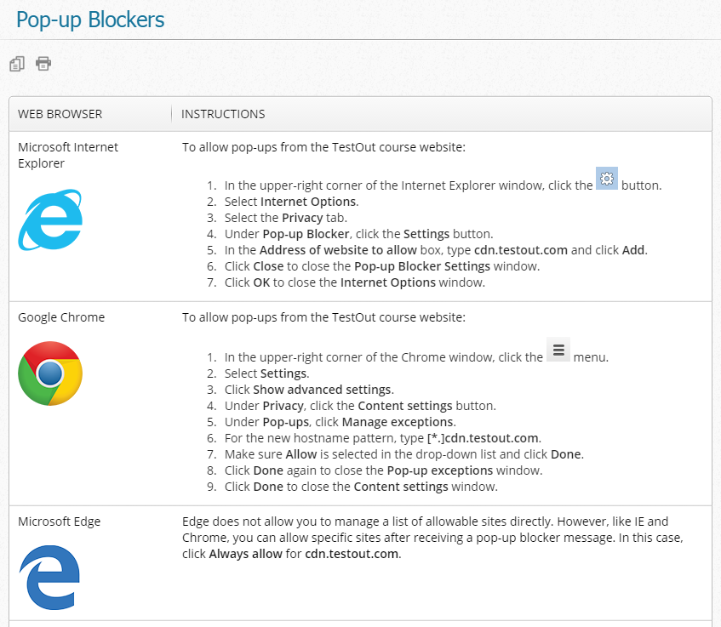
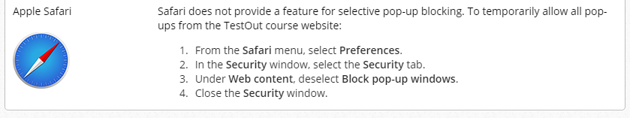

- Once you have logged in to Blackboard, click on the TestOut Office Pro menu on the left-hand side.
- When you click the link to access your homework for that class, a screen will appear like the one below. Click Launch Labsim. The first time you do this, it will ask you for an activation code. Put in the activation code you received when you purchased the LabSim.
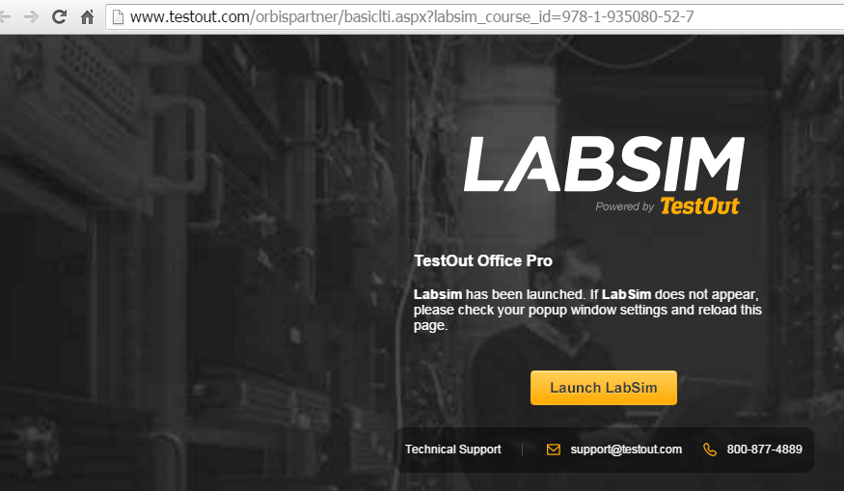
- If you get the following warning window, just click the Launch Course button to continue. Newer computers probably will not see this warning.
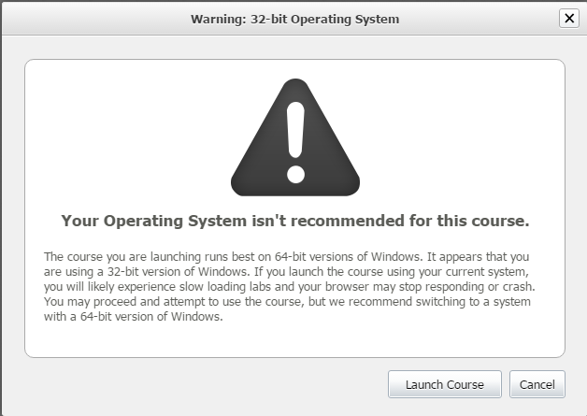
- The first time you go into the class, you may see a screen like the one shown below. Make sure you select the course with your Instructor, and click on Enroll.
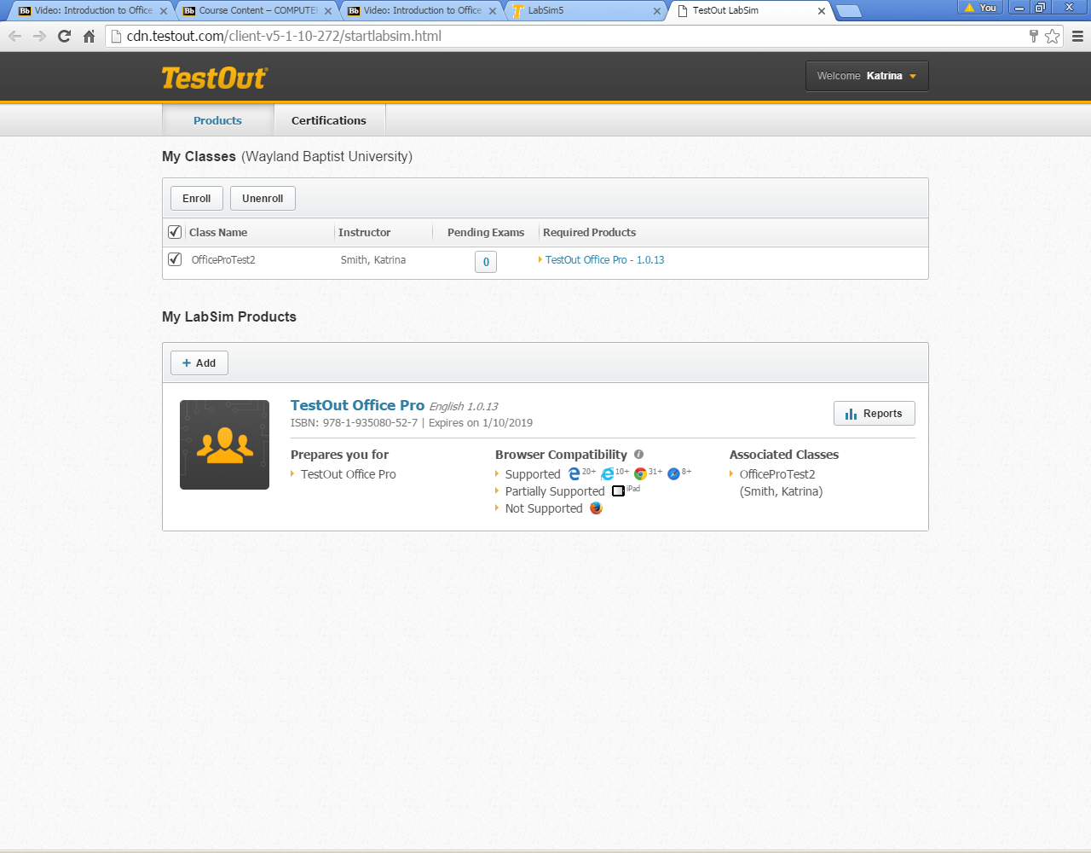
- The following screen may appear. Type your instructor name in the “Who teaches the class you want to enroll?” Window and click the magnifying glass. It should return the instructor name, as shown below. Click Select.
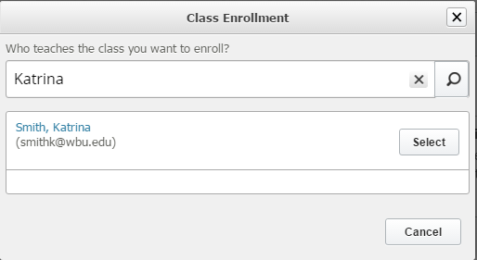
- The following screen will then appear. Click the Enroll button next to the Computer applications Winter-PLV 2016 PL01 course.
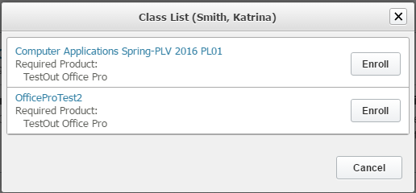

- The following confirmation screen will appear. Click Yes.
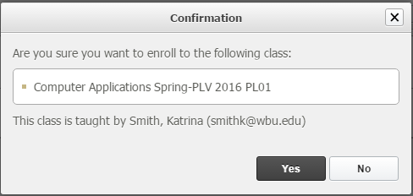

- Click on the link for TestOut OfficePro – 3.0.0 to the right of your class to access the course.
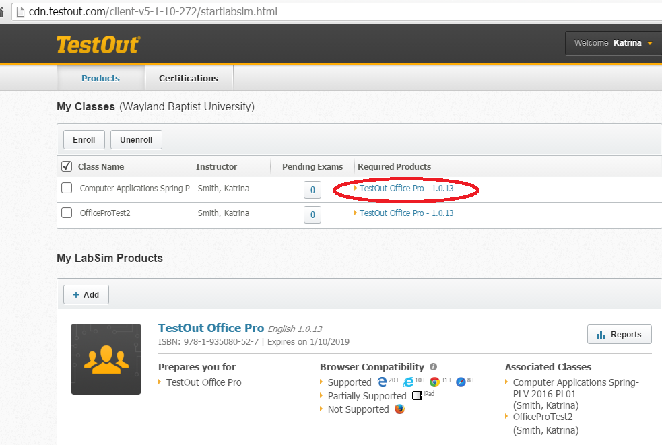
- You will be taken into the following screen. It will take you to the first lesson or where you left off last time.
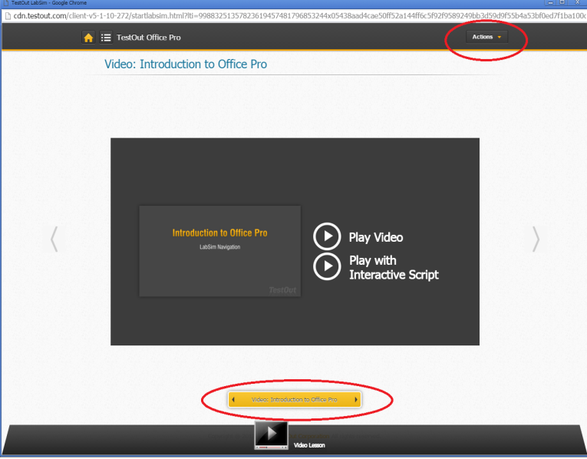
- Notice the area at the bottom of the window that is circled above. You can click the arrows on that box to navigate forward or back to the Table of Contents.
- When you wish to stop and log out, click the Actions button in the upper right-hand corner and select Log Out.

How to access your Assignments

To complete assignments for LabSim, it is crucial that you follow the correct steps in order to ensure that your grade will be recorded for the assignment in the instructor’s gradebook in Blackboard.

- Log in to Blackboard
- Click the course link for your COSC2311 course.
- Click on the Labsim link on the menu on the left-hand side of the screen.
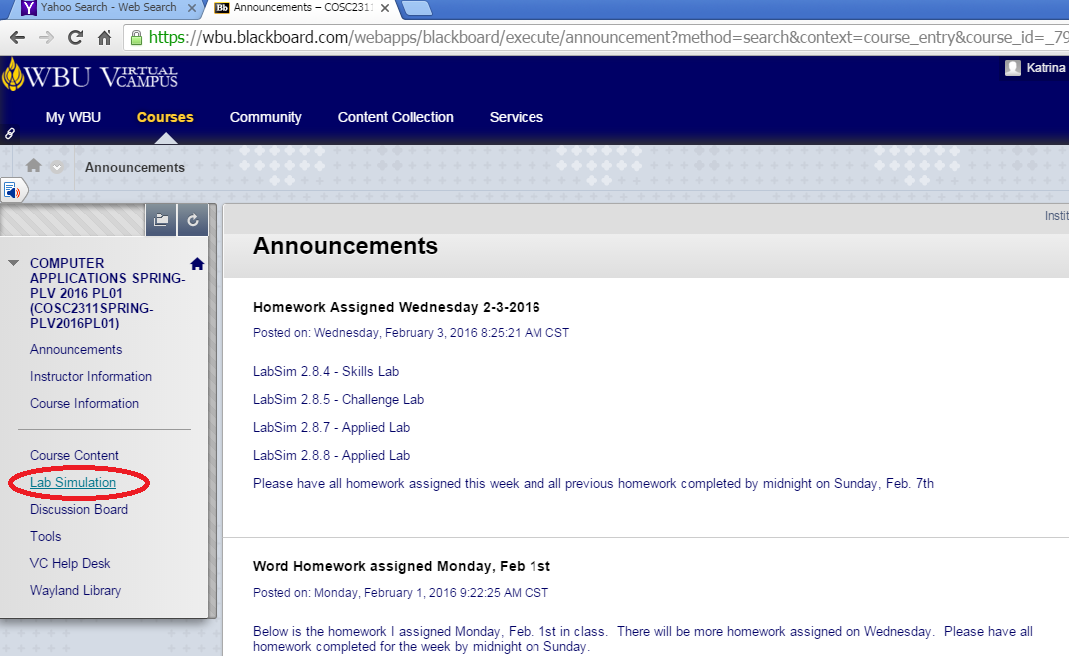
- You will then see all the sections for the LabSim course listed. Click on the section for the current coursework you will be working on, such as 2.0 Microsoft Word.
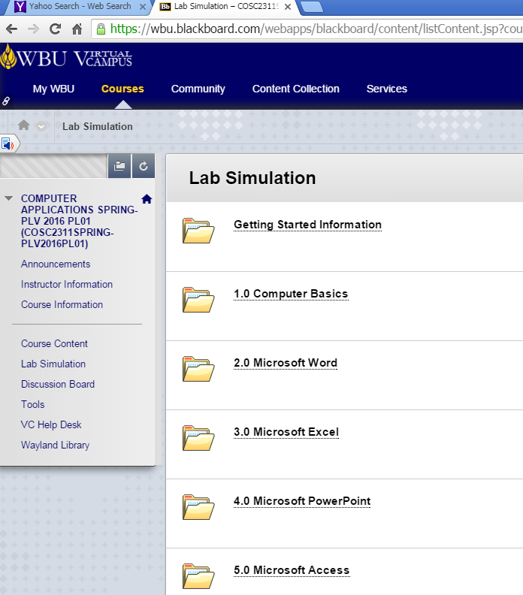
- You will then see listed the different assignments for that section.
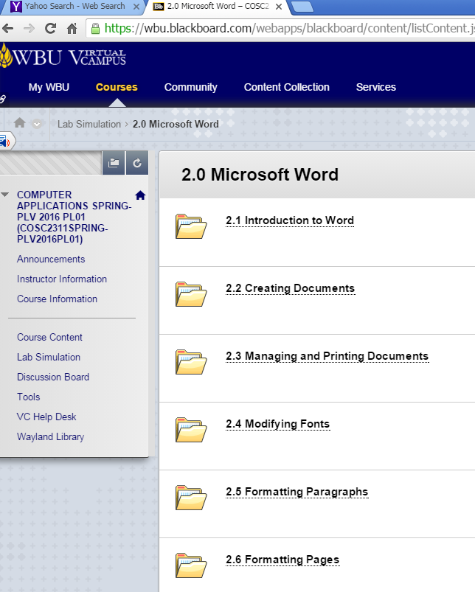
- Click on the link for the proper section in order to start working on it. You will then see the different homework assignments.

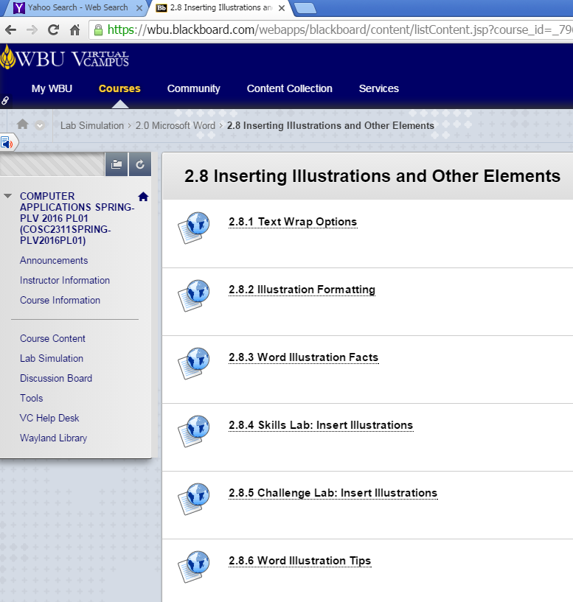
- Click on the assignment link to begin the assignment. The following screen will appear.

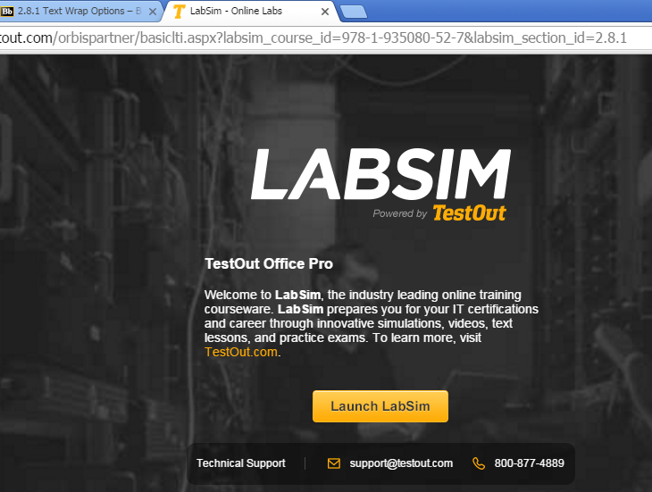

- Click on the Launch LabSim button in the middle of the screen. It will take the program a minute to load.
- If you are running a computer that is not using a 64bit Windows operating system, you may see the following message. Click the Launch Course button.
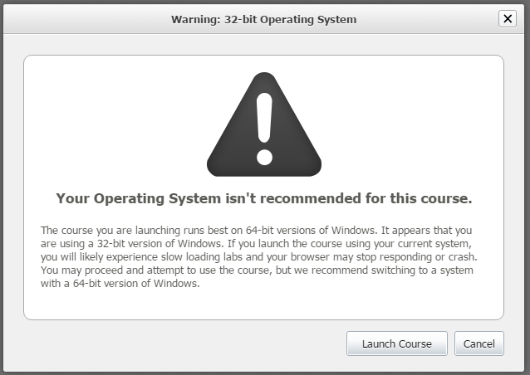
- You will then be taken in to the LabSim program. If the assignment is a video, you will see a screen like the one shown below. Click the Play Video button to watch the video.
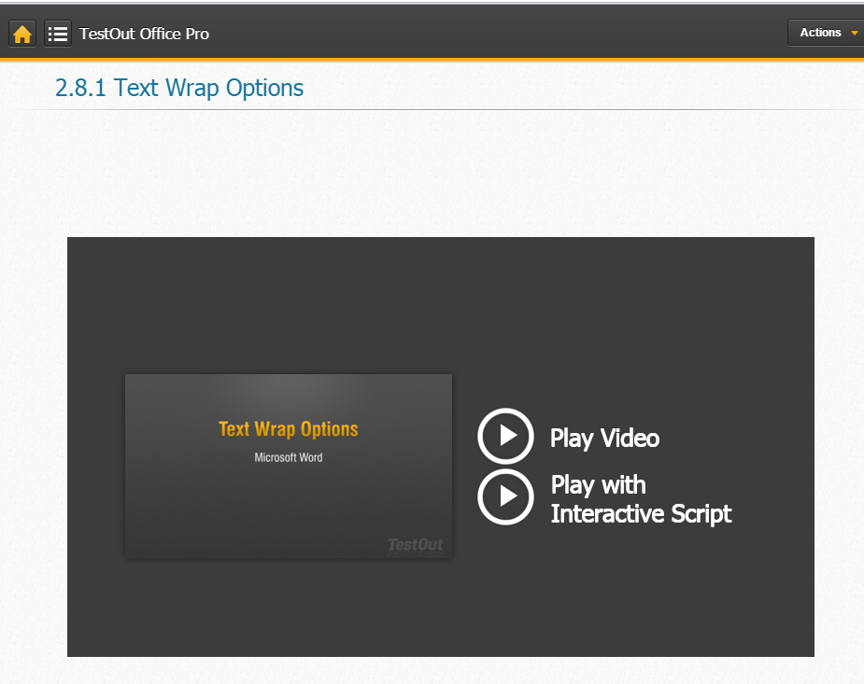
- If the assignment is a Skills, Challenge or Applied Lab, you will see a screen similar to the one shown below. When you are ready, just click the Start Lab button.
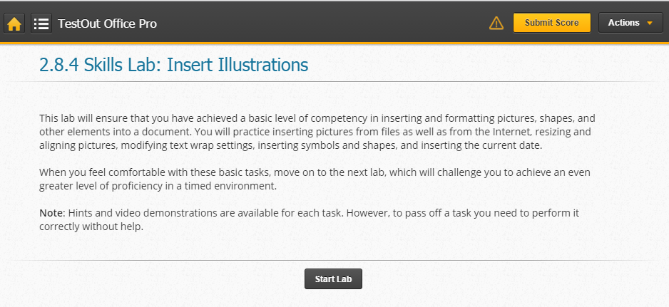
- In the upper-left hand corner of the screen, you will see an icon and menu navigation that looks like the image shown below. You can click on the menu to navigate to the next video or assignment if you want. However, if you navigate to the next assignment or lab using this menu in the LabSim program, your grade WILL NOT be recorded in the instructor’s grade book. It is very important that you start each assignment from within Blackboard in order to get your grade recorded correctly.
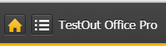
- The best habit to get into is after each assignment, you click the Actions button in the upper right-hand corner of the LabSim screen and select Log Out.
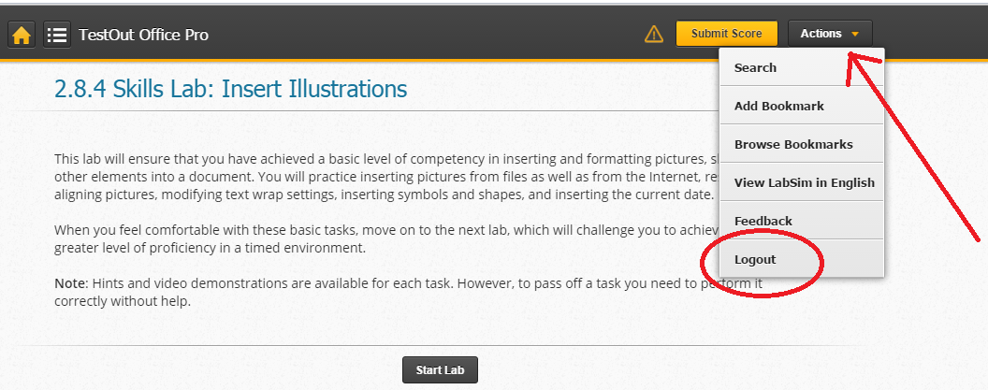
- It will then take you to the following screen.
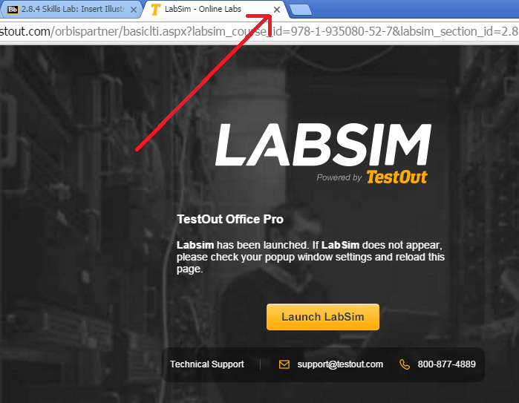
- Use the “X” to close the browser tab for LabSim. You should now see the Blackboard browser tab. Use the bread crumb trail at the top of the window to take you back one screen to see the next assignment links.
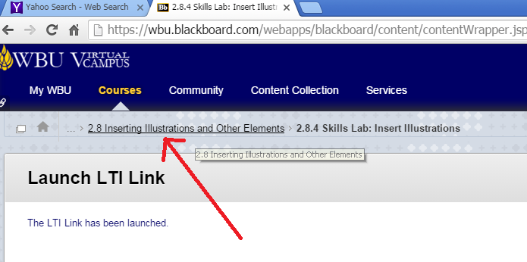
- That will take you back to the list of assignments (see the example below). Just click on the next assignment and repeat the above steps.
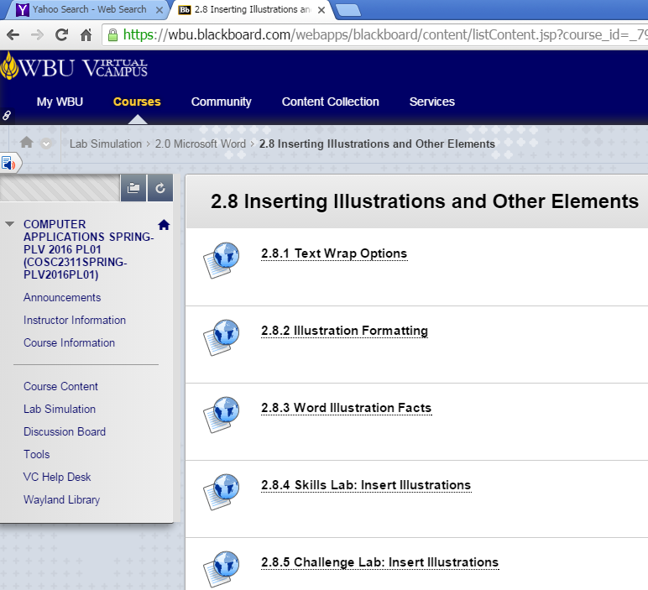
- This seems like a lot of steps for each assignment. However, if you complete the assignments as described above, it will insure that your grade gets recorded in your instructor’s grade book.
- If you work ahead in the LabSim using the menu, there is a way to get your grade to record in the grade book. See the steps below for how to correct that issue.

How you get your grade recorded for an assignment if you worked ahead using the LabSim menu instead of clicking the individual link for the assignment in Blackboard.

If you are working in the LabSim program, and you click the menu at the top left-hand corner to navigate to the next assignment, your grade will not be recorded in the instructor’s gradebook in Blackboard when you complete the assignment. The Submit button will not be available. If you completed an assignment or assignments using the LabSim navigation menu, there is a way, after the fact, to get your grade submitted to the gradebook. You can follow the steps below to correctly get your grade into the gradebook if it did not allow you to submit it after you completed the assignment.

- When you have finished your assignments in LabSim, go back into Blackboard.
- Navigate to the Section and homework assignment you were completing in Labsim.
- You will have to do this for each assignment you completed in LabSim without clicking on the link first in Blackboard. This does not always work for the Challenge Labs. You may just have to do them again.
- Click on the assignment link in Blackboard.
- It will take you to LabSim. Click on the Launch LabSim button.
- Click on Launch Course if the message comes up about using a non-64 bit Windows operating system.
- You will be taken back into LabSim and into the assignment you already completed. The screen will look like the one shown below.
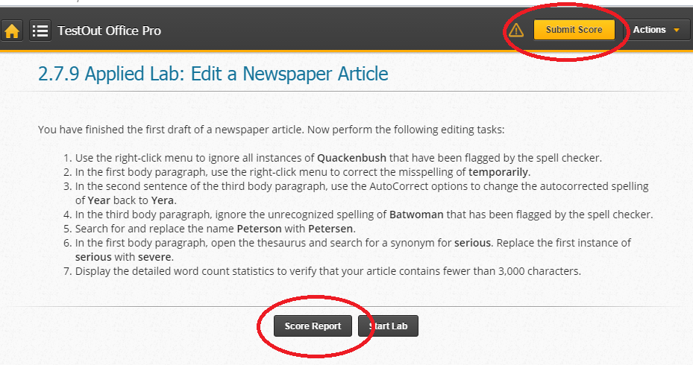
- Click the Score Report button at the bottom of the screen and make sure it shows you completed the assignment. You should see green check marks next to the items you did correctly along with a grade.
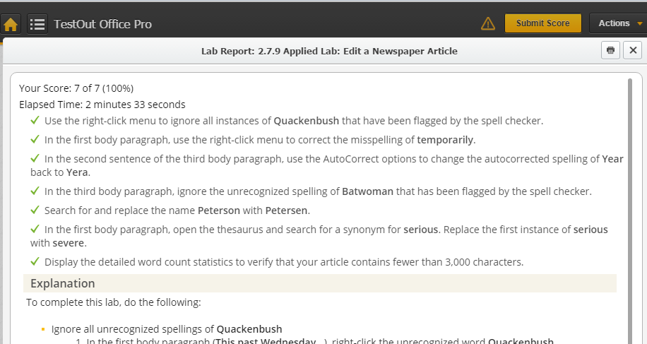
- Use the “X” in the upper right-hand corner to close out of the Score report.
- Click the Submit Score button in the upper right-hand corner. You should see a confirmation message appear on the screen, like the one shown below. Click Submit and your assignment grade will now show up in the Blackboard Gradebook for your instructor.

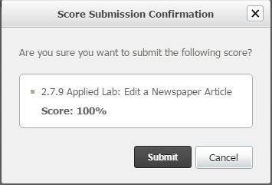
- You will get the following confirmation that your grade has been submitted. Click Close to close the confirmation box.
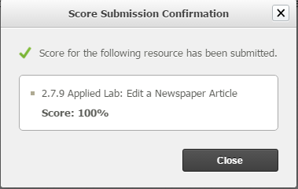
- Then click the Actions button in the upper right-hand corner and Logout of LabSim.
- Repeat the above steps by each assignment that you completed in LabSim without clicking on the link from Blackboard first.

